HUM 100 Worksheet: Realism, Impressionism, and the Modern World

Part 1:

Realism |  | Impressionism
Characteristics:  1. Depiction of the ordinary  2. Real-life situations  3. Shift from the ideal to the real |  | Characteristics:  1. The play of light in the present moment  2. Immediacy, spontaneity  3. Short, staccato brushstrokes in art
Artifact | Characteristic It Represents (Explain Your Reasoning) | Artifact | Characteristic It Represents (Explain Your Reasoning)
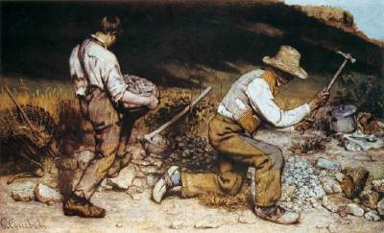  Gustave Courbet, The Stonebreakers, 1849, Oil on canvas, 165 x 257 cm (Gemäldegalerie, Dresden (destroyed))  https://www.khanacademy.org/humanities/becoming-modern/avant-garde-france/realism/a/courbet-the-stonebreakers | Depiction of the ordinary/ Real-life situations.  Courbet was a master of realism who liked to depict ordinary, real life situations. “Courbet depicts common workers who wear ripped and tattered clothing; his plight of the poor is evident and is meant to be an accurate account of the abuse and deprivation that was a common feature of mid-century French rural life”. (Harris) | 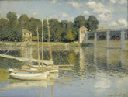  Claude Monet, The Argenteuil Bridge, 1874, oil on canvas, 60.5 x 80 cm (Musée d'Orsay, Paris)  https://www.khanacademy.org/humanities/becoming-modern/avant-garde-france/impressionism/v/monet-the-argenteuil-bridge-1874 | The play of light in the present moment, and Short, staccato brushstrokes in art.  He used short choppy brushstrokes to capture the reflections of the sailboats and the bridge.

Part 2:

Modern World
Person | Artifact Created | Medium | Need to Express
John Lennon | Imagine | Song | This song was written during the Vietnam war, he is asking us to imagine a place where things that divide people did not exist. It was written to show us that there is another way out there to live our lives; that we don’t need to hate and kill but to learn to live in peace and harmony with each other.

In one to two sentences, answer the following questions: What differences do you notice between the artifacts from each era? In the context of what you have learned in this theme, where do you think those differences stemmed from?

Realism is the effort to represent a subject truthfully. Realism paintings have more detail and are more refined. They look “real” and focused more on what was really happening in our world. The Impressionist paintings are more whimsical and artsy looking, impressionism plays with the lighting and gives off a false perspective of the surroundings. The differences stem from the fact that realism represents the subject as seen by the human eye and impressionism gives off more of the feelings and how the artist is expressing themselves in the art.

Works cited:

Harris, Beth, Dr, and Steven Zucker, Dr. "Courbet, The Stonebreakers." Realism. Khan Academy, 2017. Web. 9 Aug. 2017. <https://www.khanacademy.org/humanities/becoming-modern/avant-garde-france/realism/a/courbet-the-stonebreakers>.

Harris, Beth, Dr, and Steven Zucker, Dr. "Monet, The Argenteuil Bridge." Impressionism. Khan Academy, 2017. Web. 9 Aug. 2017. < https://www.khanacademy.org/humanities/becoming-modern/avant-garde-france/impressionism/v/monet-the-argenteuil-bridge-1874 >.

